Cloud Formation

**Cloud Formation**: AWS Cloud Formation is a service that helps you model and set up your AWS resources so that you can spend less time managing those resources and more time focusing on your applications that run in AWS. You create a template that describes all the AWS resources that you want (like Amazon EC2 instances or Amazon RDS DB instances), and Cloud Formation takes care of provisioning and configuring those resources for you.

* [Simplify infrastructure management](https://docs.aws.amazon.com/AWSCloudFormation/latest/UserGuide/Welcome.html#welcome-simplify-infrastructure-management)
* [Quickly replicate your infrastructure](https://docs.aws.amazon.com/AWSCloudFormation/latest/UserGuide/Welcome.html#welcome-quickly-replicate-your-infrastructure)
* [Easily control and track changes to your infrastructure](https://docs.aws.amazon.com/AWSCloudFormation/latest/UserGuide/Welcome.html#welcome-easily-control-and-trach-changes)

The template structure has following components.

* **Format version:**

Format version defines the capability of a template.

* **Description:**

Any comments about your template can be specified in the description.

* **Metadata:**

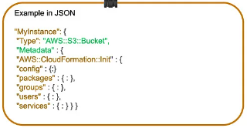

Metadata can be used in the template to provide further information using JSON or YAML objects.

* **Parameters:**

Each time you create or update your stack, parameters help you give your template custom values at runtime

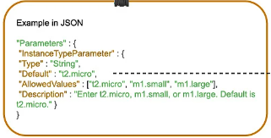

* **Mappings**

Mapping enables you to map keys to a corresponding named value that you specify in a conditional parameter

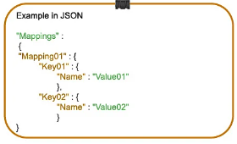

* **Conditions:**

conditions define whether certain resources are created or when resource properties are assigned to a value during stack creation or updating

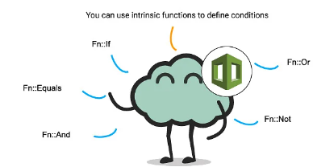

* **Transform:**

Transform builds a simple declarative language for AWS Cloud Formation and enables reuse of template components

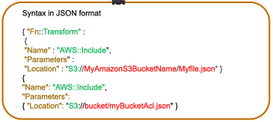

* **Resources:**

Using this section, you can declare the AWS resource that you want to create and specify in the stack

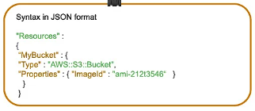

* **Output:**

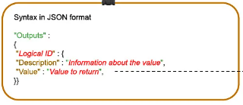

The output section describes the output values that you can import into other stacks or the values that are returned when you view your own stack properties.

Creation of IAM user, Group, Role and Polices

* **Create a stack in cloud formation**

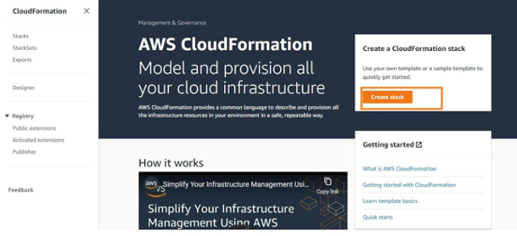

* **upload the file --> with scripted template of provisioning the resources**

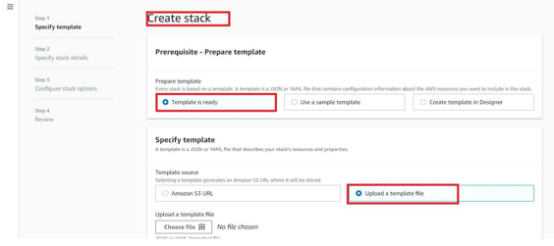

* Create a template file either in yaml or json format and upload the file in the stack.
* Specify stack details

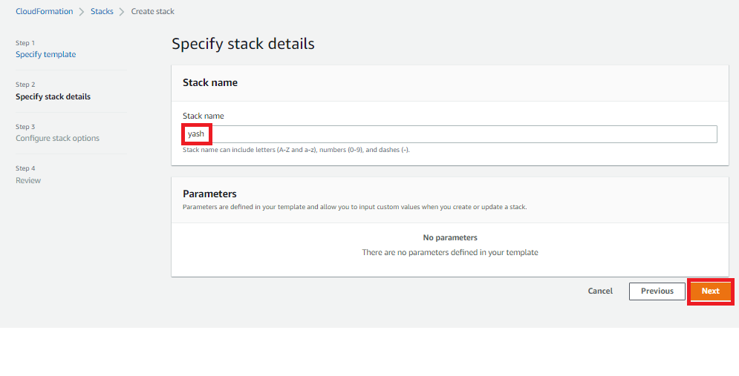

* Configure stack
* Review the cloud formation stack and create a stack
* My stack --> IAM-components is created successfully.

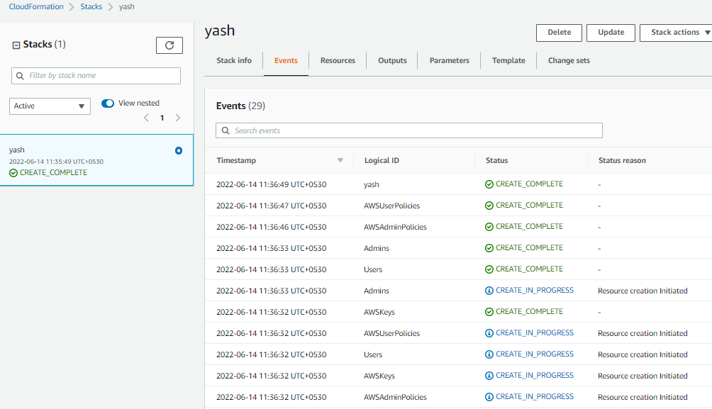

OUTPUT:

1. **I am user --> Rock and Hulk created**
2. **Hulk-user --> added to AWSAdmingroup**
3. **Rock-user--> added to AWSUsergroup**

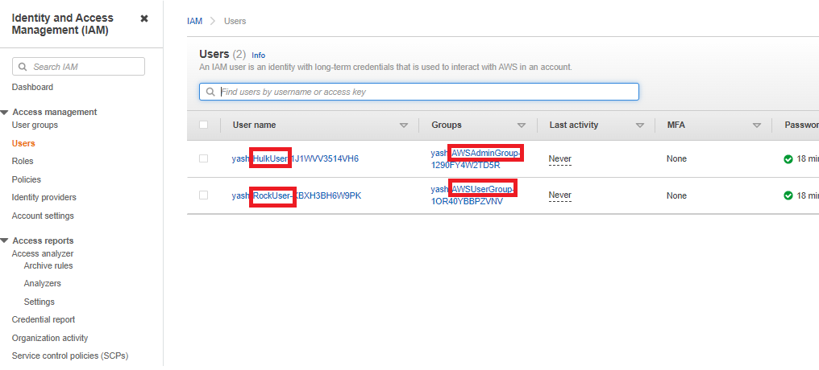

**4.AWSAdminGroup**:

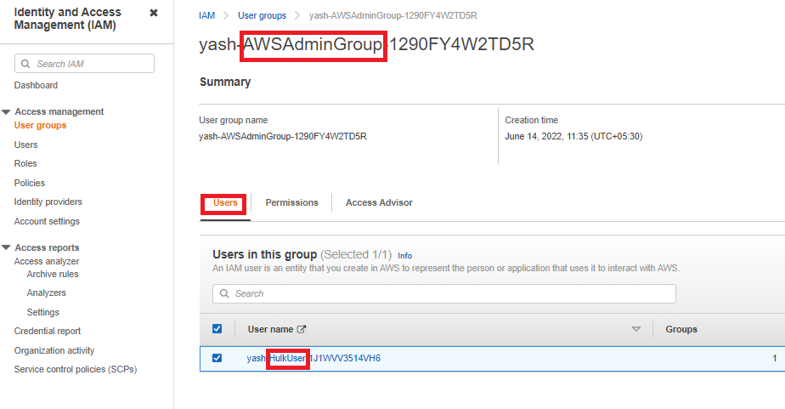

**5.IAMGroup--> AWSAdminGroup policy:**

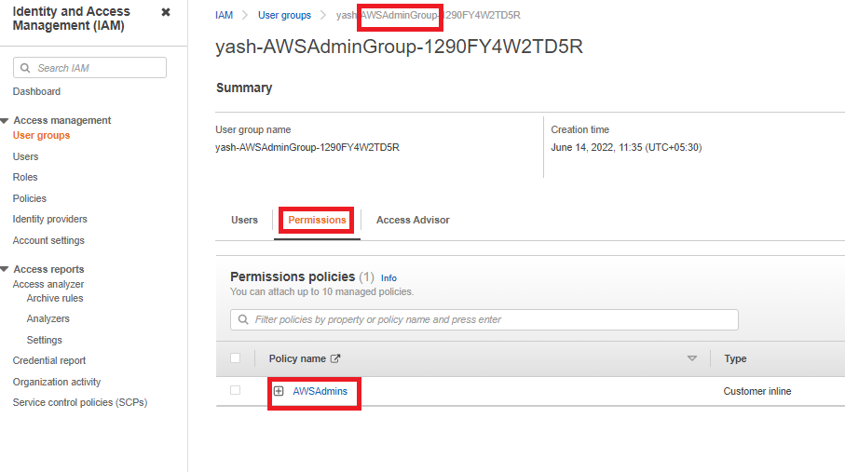

**6.AWSUserGroup**

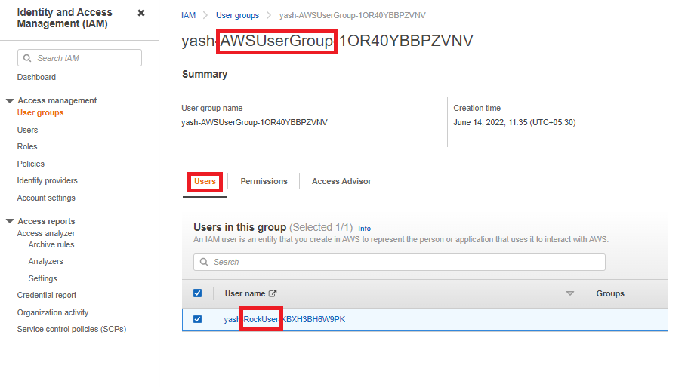

**7.IAMGroup--> AWSUserGroup Policy**:

